**Day 1 task**

1) Write a blog on Difference between HTTP1.1 vs HTTP2

| **HTTP1.1** | **HTTP2** |
| --- | --- |
| * It works on the textual format. | * It works on the binary protocol. |
| * There is head of line blocking that blocks all the requests behind it until it doesn’t get its all resources. | * It allows multiplexing so one TCP connection is required for multiple requests. |
| * It uses requests resource Inlining for use getting multiple pages | * It uses PUSH frame by server that collects all multiple pages |
| * It compresses data by itself. | * It uses HPACK for data compression. |
| * HTTP1.1 which was created in 1997. | * HTTP2 which was created in 2015. |
| * HTTP 1.1 does not include any in-built features, so the performance it delivers is less efficient. | * HTTP 2 is designed to be more efficient and performant than HTTP 1.1. This is because HTTP 2 includes several features like multiplexing, binary protocol and header compression. |
| * The client sends a request to a server, and the server sends a response back to the client. | * A different underlying protocol called Secure Remote Protocol 2 (SRP2) establishes a secure connection between a client and a server. |
| * HTTP 1.1 cannot handle buffer overflow vulnerabilities due to the lack of sufficient measures. | * HTTP 2 includes measures to prevent buffer overflow vulnerabilities. |

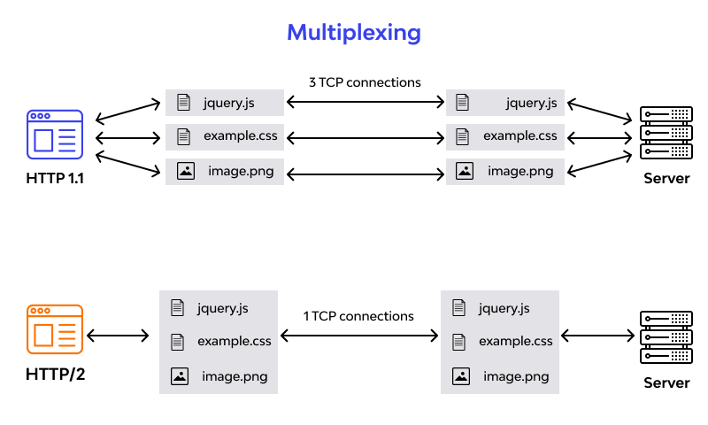

2) Write a blog about objects and its internal representation in JavaScript

Objects, in JavaScript, is it’s most important data-type and forms the building blocks for modern JavaScript. These objects are quite different from JavaScript’s primitive data-types(Number, String, Boolean, null, undefined and symbol) in the sense that while these primitive data-types all store a single value each (depending on their types).

Objects are more complex and each object may contain any combination of these primitive data-types as well as reference data-types.  
An object, is a reference data type. Variables that are assigned a reference value are given a reference or a pointer to that value. That reference or pointer points to the location in memory where the object is stored. The variables don’t actually store the value.

Loosely speaking, objects in JavaScript may be defined as an unordered collection of related data, of primitive or reference types, in the form of “key: value” pairs. These keys can be variables or functions and are called properties and methods, respectively, in the context of an object.

For Eg. If your object is a student, it will have properties like name, age, address, id, etc and methods like update Address, update Name, etc.

One of easiest way to create a javascript object is object literal, simply define the property and values inside curly braces as shown below

let student = {name: 'nishanth', age: 29, address:'Chidambaram'};